Massachusetts Distributed Generation Working Group
Service Quality Metric Recommendation
Drafted by Reid Sprite, June 14, 2013

General
The Distributed Generation Working Group (DGWG) believes that interconnection of distributed generation (DG) is a core function of Massachusetts’ utility companies and one that will be increasingly important over time. As such, both utilities and DG stakeholders agree that it is appropriate to enforce timelines laid out in the DPU Interconnection Tariff.
On March 13, 2013, the DPU issued an Order (DPU 11-75-E) approving the Timeline of the recommendations in the DG Working Group Report and directed the utilities to file compliance tariffs within 30 days (stamp approved on May 2, 2013). More background materials about this Order are available at the DG Working Group Web Page.
Further, it is noted that Massachusetts Bill S.2395, “An Act relative to competitively priced electricity in the Commonwealth”, stipulates that:
“The department of public utilities shall develop an enforceable standard interconnection timeline for the interconnection of distributed generation facilities. Timelines may vary depending on the size and type of the facility or other factors as determined by the department. The department shall implement such timeline not later than November 1, 2013. The department shall enforce established timelines as part of its service quality standards review under section 1I of chapter 164 or by whatever enforcement mechanism is determined appropriate by the department.”
In accordance with this legislation and DPU Order 11-75-E, the DGWG recommends that the Department enforce timelines as part of a stand-alone distributed generation service quality standard and describes below a proposal for discussion.

Timeline Measurement
As part of the agreement between the utilities and the non-utility parties, the utilities have begun reporting timeline measurement for each step of every project on a monthly basis. The DG tariff explicitly outlines the number of work days the utilities and the interconnecting customer have to be considered compliant. The DGWG believes that timeline measurement for enforcement purposes should be based on the total time for an application to be processed and approved, rather than performance on each individual step. To that end, the DGWG proposes that the measurement of time to process and approve an application should commence upon a utility’s receipt of a complete application and terminate upon the delivery of a fully-executed Interconnection Service Agreement to the interconnecting customer. As is demonstrated in new reporting, delays that are a result of the customer’s non-compliance with the tariff are tracked and reported, enabling analysis to determine “Utility Time Lapsed” for the timelines in the tariff.

Incentives and Penalties
The source of funds for penalties and incentives shall be derived from revenue collected by the utility for the purpose of interconnecting distributed generation. These revenues include: application fees, study fees, and required system upgrades. This combination of fees is defined as the Calendar Year DG Revenues. The Calendar Year DG Revenues will be capped at 2.5% of each utility’s gross revenue for the same year.
By point of reference, the Legislature has limited penalties to no more than 2.5% of each utility’s gross revenues. Below is a table provided by DOER in Initial Comments for DPU 12-120 (Service Quality Docket) demonstrating the scale of the 2.5% cap relative to Net Income.
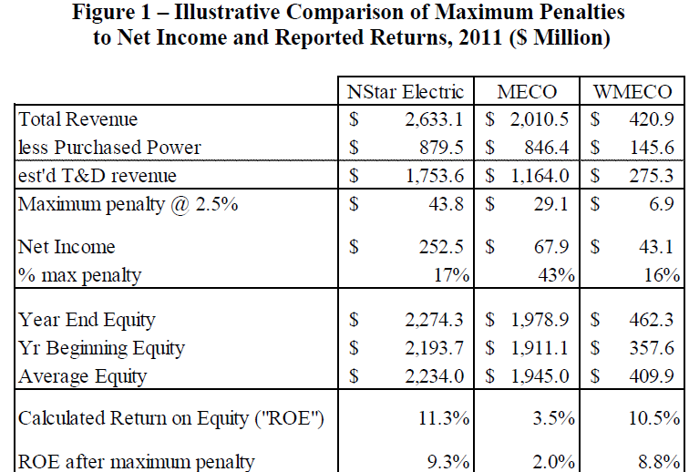
Penalty funds shall be set aside in an account managed by the DOER. In the event that the balance of the account exceeds $5,000,000, funds in excess of this amount shall be used to support distributed generation projects in the Commonwealth and to address high priority interconnection issues, the protocols for which shall be established at DOER’s discretion.
Incentives will also be paid from this account. In the event a utility has a net incentive in a given year, the appropriate incentive amount will be dispersed to the utility in the form of a monetary payment. It is important to note that all funds that are in this account are a result from a previous penalty payment. In the event that the account does not have sufficient funds to pay an incentive payment, a credit will be built up that can offset a future penalty in the following. Credits shall not rollover past this one year period. Credits cannot be dispersed as cash or used to offset other Service Quality metrics.

DG Service Quality Standard Metrics
The DGWG recognizes the more traditional, and likely default outcome of having DPU- adjudicated performance metrics without this agreement might lead to establishing a host of metrics within an “Interconnection Category” with the only possibility of an “incentive” taking the form of offsets, whereby good performance in some metrics would mitigate poor performance in others. This proposal offers the option of deriving a score for each process track and the pre-application report.
Each project track is weighted with the following percentage:
Track | Weight
Pre-Application Report | 5%
Simplified | 10%
Expedited (w/o Supplemental Review) | 15%
Expedited (w/ Supplemental Review) | 15%
Standard (Early ISA) | 17.5%
Standard | 17.5%
Standard (Complex) | 20%

The metric used to calculate a penalty or incentive is based on the number of applications that comply and do not comply with tariff timelines in each category. Penalties are applied for each application that exceeds the tariff timelines, and incentives are applied for each application that is completed 20% faster than the tariff guidelines. An example calculation is shown in Section 6.

The penalty or incentive for each track is defined as:
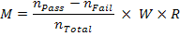
Where:
= Monetary penalty or incentive (in dollars)
= Number of applications in track completed 20% faster than tariff time line
= Number of applications in track not completed within tariff time line
= Total number of applications in track
= Track Weight (as percentage)
= Calendar Year DG Revenue (in dollars)

Benchmarking
Because the current DG tariff lays out explicit timeline compliance requirements and the new tariff only went into effect on May 1, 2013, the DGWG finds that historic benchmarking is inappropriate for evaluating utility performance. Furthermore, there are mechanisms built into the tariff that require the utilities to comply with the tariff with an assumption of improved performance over time.

Calculation Example
Calendar Year DG Revenues = $10,000,000
 | Pre-application Report | Simplified | Expedited (w/o Suppl. Review) | Expedited (w/ Suppl. Review) | Standard (Early ISA) | Standard | Standard (Complex) | Total
Number of Applications | 100 | 200 | 75 | 60 | 25 | 20 | 5 | 485
Number of Applications Exceeding Timeline | 20 | 10 | 30 | 50 | 20 | 5 | 4 | 139
Number of Applications In Compliance | 30 | 150 | 40 | 10 | 4 | 10 | 0 | 244
Number of Applications Beating Timeline by 20%+ | 50 | 40 | 5 | 0 | 1 | 5 | 1 | 102
Track Weight | 5.0% | 10.0% | 15.0% | 15.0% | 17.5% | 17.5% | 20.0% | 100%
Max Penalty/Incentive | $500,000 | $1,000,000 | $1,500,000 | $1,500,000 | $1,750,000 | $1,750,000 | $2,000,000 | $10,000,000
Actual (Penalty)/Incentive | $150,000 | $150,000 | ($500,000) | ($1,250,000) | ($1,330,000) | $0 | ($1,200,000) | ($3,980,000)

https://sites.google.com/site/massdgic/home/interconnection/distributed-generation-working-group

