Electric System Bulletin No. 756 Appendix C:

Distributed Generation Connected To National Grid Distribution Facilities Per The Massachusetts Standards for Interconnecting Distributed Generation

April 2012 version 2.0

ESB 756 Appendix C is part of the ESB 750 series



PREFACE
Electric System Bulletin 756 APPENDIX C is a technical bulletin covering Massachusetts Electric Company and Nantucket Electric Company d/b/a National Grid Standards for Interconnecting Distributed Generation M.D.P.U. No 1176* (Canceling M.D.T.E. No. 1116-A) Effective: December 1, 2009.
* https://www.nationalgridus.com/non_html/Interconnect_stds_MA.pdf
This is an appendix to ESB 756 and is available from the Company’s web site and may be obtained:
- From the Internet at http://www.nationalgridus.com/electricalspecifications,
- Or in printed form by contacting either of the Call Centers in Massachusetts or New York (see inside cover of ESB 750). However, printed copies are not document controlled, so for the latest authorized version please refer to the Company’s website.

TABLE of CONTENTS
SECTION PAGE
TABLE of CONTENTS 3
1.0 Purpose 4
2.0 Scope 5
3.0 Customer Interface Procedures 5
3.1 Application Process Overview 5
3.2 Objectives in the Application Process 5
3.3 Considerations During the Application Process 7
3.4 Interconnection Charges 8
Table 3.4-1: DG Projects where no EPS upgrades are expected 8
Table 3.4-2: Complex DG Projects 8
4.0 Overview of Potential Issues Related to Interconnection 9
Illustration 4.6-1: Typical DG Installation Areas on Radial Distribution Feeders 10
Table 4.6-1: Typical Planning Limits for DG Connection to Radial Distribution Feeder 10
5.0 General Design and Operating Requirements 12
5.1 Applicable Codes, Standards, and Guidelines 12
5.2 Definitions 13
5.3 General Criteria 13
5.3.1 Single Phase 13
5.3.2 Three Phase 13
5.3.3 Phase Balance 13
5.3.4 Neutral Stabilization and Grounding 13
5.4 Service Equipment and Revenue Metering 14
5.4.1 Service Equipment Requirements 14
5.4.2 Company Revenue Metering Requirements 14
5.5 Transformer 14
5.5.1 Purpose for DG Facility Interconnecting Transformer 14
5.5.2 Secondary Served DG Customers 14
5.5.3 Primary and Higher Voltage Served DG Customers 14
5.5.3.1 Effectively Grounded, Four-wire Multi-grounded 3-phase Wye EPS: 15
5.5.3.2 Not Effectively Grounded, Three-wire 3-phase EPS: 15
5.6 Manual Generator Disconnect Switch 15
5.7 Protective Device Equipment 16
5.7.1 Protection Requirements 16
5.7.2 Interconnection Interrupting Device 16
5.7.3 Interconnection Transformer Configuration 16
5.7.4 Instrument Transformers for Protective Device Relays 16
5.7.4.1 Current Transformers (“CT”) 16
5.7.4.2 Voltage Transformers (“VT”) and Connections 16
5.7.5 Synchronizing Devices 17
5.7.6 Voltage Relays 17
5.7.7 Frequency Relays 17
5.7.8 Overcurrent Relays 17
5.7.9 Type Tested Equipment 17
5.7.10 Non-Type Tested Equipment 17
5.7.10.1 Photovoltaic (PV) Generation 17
5.7.10.2 All Other Parallel Generation Equal or Above 500kW 18
5.7.10.3 Protective Relay Hard-Wire Requirement 18
5.7.10.4 Interconnection Interrupter Tripping and Protective Relay Supply 18
5.7.10.5 Use of Microprocessor Based Relays 18
5.7.11 Utility Grade Protective Device Settings and Verification 19
5.7.11.1 Company-designated Relays and Customer Settings 19
5.7.11.2 Company Verification of Relay Testing 19
5.7.12 Anti-islanding 19
5.7.12.1 Inverter-based Photovoltaic (PV) Generation 19
5.7.12.2 All Other Parallel Generation Except PV Generators 20
5.7.12.3 High-Speed Protection 20
5.7.12.4 DTT Installation Requirements 20
5.7.13 Power Quality Compliance Verification 20
6.0 OPERATING 21
6.1 Power Factor 21
6.2 Power Quality Monitoring 21
6.3 Isolation 21
6.4 Energy Management System-Remote Terminal Unit (EMS-RTU) 21
6.5 Balance of Customer Equipment 22
7.0 REVISION HISTORY 22
EXHIBITS ATTACHED 22
EXHIBIT 1: M.D.P.U. 1176 Tariff 23
EXHIBIT 2: Company Requirements for Projects Not Eligible for the Simplified Process 26
EXHIBIT 3: Reference Maps of National Grid Massachusetts Secondary Network EPS Areas 27
EXHIBIT 4: Distribution Secondary Grid Network Description 28
EXHIBIT 5: Recommended Guidelines for Residential and Commercial Single-line Diagram Submittals 29
FIGURE 1: sample residential Photovoltaic distributed generator installation – Single Phase, Net Metering 30
FIGURE 2: sample commercial distributed generator installation 31
EXHIBIT 6: Recommended Guidelines for Functional Single-line Diagram Submittals 32
FIGURE 3: sample functional single-line diagram 33
FIGURE 4: typical 3v₀ requirements for local eps ground fault detection 34
EXHIBIT 7: Typical Overhead Primary Service Configuration for Large DG Installations >500kW 35
EXHIBIT 8: net metering compliance verification checklist (Simplified Process) 36

Purpose
- National Grid strongly believes that promoting the installation of Distributed Generation (DG) facilities, in accordance with the Massachusetts Standards for Interconnecting Distributed Generation (MA SIDG or SIDG), is sound public policy. This belief includes DG facilities on network systems to the extent technically feasible.
- The purpose of this Electric System Bulletin (ESB) is to assist customers desiring to interconnect DG projects to National Grid’s Massachusetts distribution system for State jurisdictional projects. If a project will be selling energy to a third party, not National Grid as a Qualifying Facility (QF) or under the net-metering tariff, then the project is FERC jurisdictional. As such, the Customer will need to apply and work with the ISO-NE (http://www.iso-ne.com/genrtion_resrcs/nwgen_inter/index.html) for interconnection to the distribution system, following the application requirements of the FERC Small Generator Interconnection Procedure (SGIP) and ISO-NE Schedule 23.
- This ESB supplements ESB 750 and the MA SIDG and provides general technical requirements, recommendations, and assistance to customers regarding the DG facilities connected in parallel to the Company’s distribution electric power system (Company Distribution EPS). These projects are typically 5 MWs or smaller in size. Note that the SIDG does not apply to DG units larger than 10 MW.

Scope
- All generating interfacing equipment must be designed, installed, interconnected, tested, and operated in accordance with applicable government, industry, and Company standards. The provisions of this bulletin only pertain to those types of parallel generation covered by the MA SIDG connected to the Company Distribution EPS that are net metered generation sources (Net Metered Classes) or non-net metered generation sources. For FERC jurisdictional projects connected to the Company Distribution EPS, the technical provisions of this document also apply.
- These requirements are limited to only those points in which the Customer and the Company have a mutual interest to ensure safety to Company employees and the public and satisfactory operation and compatibility with the electrical supply to others served by the Company distribution EPS.
- Technical requirements for parallel operated on-site generators (OSG) not covered by this document may be found in ESB 756 Appendix A.

Customer Interface Procedures

Application Process Overview
This section outlines the process for a Customer to receive Company approval to interconnect DG facilities to the Company Distribution EPS. This process is intended for the following:
- New DG facilities that are eligible under the MA SIDG process;
- Review of any modifications affecting the Company Distribution EPS and service connection interface at the point of common coupling (PCC) of existing Customer DG facilities that: (i) are eligible under the SIDG process; and (ii) have been interconnected to the Company Distribution EPS where an existing retail interconnection agreement between the Customer and the Company is in place; and
- In all other cases, the Company will, where possible, use a similar application and approval process as outlined in the SIDG for DG types of facilities.
This application process and its requirements do not apply to generation equipment that will never be allowed to operate in parallel with the Company Distribution EPS. For example, this process does not apply to emergency standby generators with break-before-make transfer switches and any other generation sources that operate independently of any connection to the Company Distribution EPS and have no provision for such connection (even for a short period of time).
As stated above, this application process is mandated by the Massachusetts Department of Public Utilities (DPU) for customer generation equipment that will be connected to the Company Distribution EPS on a full or part time basis; see MA SIDG contained in National Grid’s Massachusetts and Nantucket electricity tariff, M.D.P.U. 1176 (https://www.nationalgridus.com/masselectric/non_html/rates_tariff.pdf).

Objectives in the Application Process
- Parallel operation of a generator becomes a part of the Company Distribution EPS and where the Customer and the Company have a mutual interest the interconnection is required to preserve the safety, reliability, security, power quality, and operational efficiency needs of the Company Distribution EPS. This is necessary to ensure safety to the public and to Company employees and satisfactory operation and compatibility with the electrical supply to others. The steps and timing requirements of the application process are identified within the MA SIDG. Although timing is driven by the SIDG, the time required to complete necessary engineering studies may depend on the characteristics of the generator, the size class (as specified above), its intended operating modes, customer submittal of technical data and design, and the characteristics of the Company Distribution EPS at the point of interconnection (POI).
- Additional site-specific requirements may be indicated once the supply voltage, service arrangement, location, and generation purpose is determined, where such purpose can be either:
- peak shaving*,
- net energy metering for solar, wind, or agricultural projects as under the Company’s net-metering tariff, M.D.P.U. 1177, or
- export energy for a QF with an agreement for sales** according to the Company’s tariff provisions.
* Peak shaving generation is Customer-owned generation operated in parallel with the Company to reduce a Customer’s electrical demand. Unlike net metering, peak shaving generation is not permitted to flow into the utility supply system upstream of the billing meter and will require the installation of protection devices. The Company’s revenue metering is detented in this case to prevent reverse billing meter registration.
** An Agreement for Sales of Export Energy for a QF under a MA SIDG application may be made per the Company’s M.D.P.U. 1032-C electricity tariff and is a Power Purchase Agreement.
- For new electric service or modifications to electric service to accommodate the Customer’s parallel generator, refer to the Company’s latest revision of ESB No. 750, Specifications for Electrical Installations. The Customer will be responsible for any permitting and conformance to the latest revision of all local, state and federal codes and national standards that apply. For example, under MA and municipal building code requirements the Customer will need to provide evidence of electrical inspection approval from their local municipal code enforcement agency.
- When considering a DG interconnection arrangement, an M.D.P.U. 1176 Exhibit A or B application is submitted to the Company’s Distributed Generation Services department.
- Any subsequent sale of an On-Site Generator (OSG) facility covered by the requirements of the MA SIDG of the original retail Customer’s facility will require the new owner to establish a separate interconnection agreement (M.D.P.U. 1176 Exhibit F and/or G) for the generation.
- Refer to:
- The steps to install distributed generation in Massachusetts as specified in the MA SIDG; see Section 3.0 of M.D.P.U. 1176 (https://www.nationalgridus.com/masselectric/non_html/rates_tariff.pdf),
- Attached Exhibit 1 from the Company’s electricity tariff, M.D.P.U. 1176 (https://www.nationalgridus.com/masselectric/non_html/rates_tariff.pdf), Figures 1 and 2 and Table 1 application process,
- Attached Exhibit 2 for Company requirements for projects not eligible for the Simplified Process,
- The Company’s Technical Sales & Engineering Support (TSES) department’s electronic mail address as follows for inquiries: Distributed.Generation@nationalgrid.com, and
- The Company’s (www.nationalgridus.com) “Distributed Generation” web site at https://www.nationalgridus.com/masselectric/home/energyeff/3_renewable.asp for information and forms listed below (from M.D.P.U. 1176 https://www.nationalgridus.com/non_html/Interconnect_stds_MA.pdf) when making an application with the Company:
- Simplified Process application form and service agreement (Exhibit A)
- Expedited and Standard Process application form (Exhibit B)
- Supplemental Review Agreement (for those projects which have failed one or more screens in the Expedited Process) (Exhibit C)
- Impact Study Agreement under the Standard Process (Exhibit D)
- Detailed Study Agreement (for the more detailed study under the Standard Process which requires substantial System Modifications) (Exhibit E)
- Schedule Z Additional Information Required for Net Metering service
- Interconnection Service Agreement (Exhibit F)
- Agreement between the Company and the Company's Retail Customer (Exhibit G)
- The following Independent System Operator-New England (ISO-NE) requirements apply under this bulletin:
      - DG projects 60kW or larger that will export power require asset registration by the Company’s TSES department to ISO-NE.
      - DG projects greater than 1 MW but less than 5 MW will require a notification by the Company’s TSES department to ISO-NE via Attachment 4 under ISO-NE Planning Procedure (PP) 5-1.
      - DG projects greater than 5 MW will require a review of transmission system impacts and a Proposed Plan Application filed with ISO-NE. Refer to ISO-NE PP 5-1.
- The application process and attendant services are offered by the Company on a non-discriminatory basis to any customer. As part of the process, the Company may identify the need for detailed engineering studies, distribution system upgrades and additional protection requirements. As allowed by the Massachusetts DPU, the costs of the detailed study and upgrades are the responsibility of the Customer. If the Customer makes significant changes in the design or scheduling of their DG project, then any previous information furnished by the Company to the Customer is subject to review and possible change, which may cause a delay in service.
- The application process is structured to allow the Customer to review each cost in advance so that the Customer may choose whether or not to continue moving forward with the process prior to committing to these costs. This avoids unnecessary expenditure of resources by either party and is for the benefit of both the Customer and the Company. Where a service upgrade is necessary and is above the base interconnection cost limits in the SIDG, refer to the Company’s Terms and Conditions for Electricity Service, M.D.P.U. 1192 (https://www.nationalgridus.com/masselectric/non_html/rates_tariff.pdf) and ESB 750 (https://www.nationalgridus.com/non_html/shared_constr_esb750.pdf).
- The following website contains the Company’s application of the MA SIDG net metering rules: https://www.nationalgridus.com/masselectric/home/energyeff/4_net-mtr.asp.

Considerations During the Application Process
- When applying for a DG interconnection within the Company’s secondary area network and secondary spot network EPS located in the downtown districts of Brockton, Lynn, and Worcester in Massachusetts, DG installations on distribution secondary network systems may require a study to be undertaken to ensure the DG facility does not degrade the reliability, power quality, safety, or operation of the Company’s network system. Therefore, customers in the downtown districts of Brockton, Lynn, and Worcester should contact the Company’s TSES department (Distributed.Generation@nationalgrid.com) to determine if the proposed location is served by a distribution secondary network system. This should be done while the project is still in the planning stage, and certainly before purchasing equipment or beginning installation. The Company’s TSES department will review the Customer’s plans and discuss options with the Customer. Refer to attached Exhibit 3 for area maps locating the Company’s secondary network service areas [to be developed].
Unlike radial distribution systems that deliver power to each customer in a single path from source to load, underground secondary area network systems deliver power to each customer through a complex and integrated system of multiple transformers and underground cables that are connected and operate in parallel; refer to attached Exhibit 4 for more information. The connection of customer DG facilities on networks is an emerging topic, which (i) poses some issues for the Company to maintain adequate voltage and worker safety and (ii) has the potential to cause the power flow on network feeders to shift (i.e., reverse) causing network protectors within the network grid to trip open. Therefore, to ensure network safety and reliability additional information will be required for the Company’s engineering analysis such as:
- Customer’s existing* or proposed electric demand profile showing minimum load during peak generation time,
- Customer’s expected generation profile shown for a 24-hour period and typical 7-day duration, and
- Customer’s complete electric service single-line diagram showing the configuration of the proposed generation and other metered tenants, if any, up to the service point supplied by the Company’s secondary network EPS.
* In addition, the Company may need to install recording equipment at all metered electricity users to determine the total demand of the building’s network service when obtaining the service connection’s electric demand profile. The cost to the Customer will be according to the Company’s electric customer load survey flat rate and charged in accordance with the terms of the Company’s electricity tariff and MA SIDG.
- For more technical information on parallel generator installations, please refer to this bulletin’s remaining sections.

Interconnection Charges
Customers shall be subject to charges for interconnection costs. To permit interconnected operations with a customer, the Company may incur costs. These costs, called interconnection costs, are directly related to the installation of those facilities the Company deems necessary for interconnection. They include initial engineering evaluations, purchase and installation of additional switching, transmission, distribution, and communication equipment at Company’s facilities, safety provisions, engineering and administration. These costs shall be paid in full by the Customer prior to commencement of service in accordance with the Company’s electricity tariffs, M.D.P.U. 1176 and 1192 and the MA SIDG. For typical Company interconnection cost items expected in DG projects that will be defined in either an Impact or a Detailed Study, see the following two tables. Costs will be determined according to the Company’s electricity tariff and the MA SIDG.

Table 3.4-1: DG Projects where no EPS upgrades are expected
Item No. | Typical Company Support Activities Attributed to DG Customer's Project
1 | Engineering acceptance review of DG Customer's construction design submittals where the Company has mutual interest such as service connection facilities, meter mounting provisions, Company-designated protective devices and control schemes according to the Company’s ESB 750 series.
2 | Revenue metering equipment changes/additions.
3 | Field audit of DG Customer installation to accepted design.
4 | Field compliance verification - witness tests of DG Customer protective devices coordinating with the Company Distribution EPS.
5 | TSES Project Management

Table 3.4-2: Complex DG Projects
Item No. | Typical Company Support Activities Attributed to DG Customer's Project
1 | Company Distribution EPS upgrades (e.g., Current Limiting Fuses, Primary Conductors, Line Reclosers, Switches, Voltage Regulators, Capacitors, etc.) as a result of DG impact.
2 | Where Local EPS anti-islanding protection is required, DTT transmit addition to Distribution EPS substation feeder breaker (and/or Line Recloser) for DG impact on distribution feeder.
3 | Where Company-provided Radio Communications can be applied, additions to support DTT equipment at Distribution EPS substation feeder breaker (and/or Line Recloser) for DG impact on distribution feeder.
4 | Where Local EPS feeder selectivity may require prompt control measures for DG impact on distribution feeder operations, EMS-RTU (status & control) addition at the DG facility.
5 | Service Connection modifications and additions for DG impact on the Company Distribution EPS.
6 | Revenue metering equipment changes/additions.
7 | Engineering acceptance review of DG Customer's construction design submittals where the Company has mutual interest such as service connection facilities, meter mounting provisions, Company-designated protective devices and control schemes (e.g., DTT receive package installation at DG) according to the Company’s ESB 750 series.
8 | Field audit of DG Customer installation to accepted design.
9 | Field compliance verification - witness tests of DG Customer protective devices coordinating with the Company Distribution EPS.
10 | Project Management (TSES, Distr. Line, Distr. Station, etc.)

Overview of Potential Issues Related to Interconnection
- Customer generation connected to the distribution system can cause a variety of system impacts including steady state and transient voltage changes, harmonic distortion, and increased fault current levels. Parallel generation systems, which located individually on higher capacity feeders may not cause very serious impacts, can, on weaker circuits, in aggregation or in special cases (such as lightly loaded networks), significantly impact the Company’s Distribution EPS.
- An Impact Study and a Detailed Study in some cases is needed to identify the severity of system impacts and the upgrades needed to avoid problems on the Company Distribution EPS. Typically, an Impact or Detailed Study will be performed by the utility to determine if the proposed generation on the circuit results in any relay coordination, fault current, and/or voltage regulation problems.
- There is a wide range of potential issues associated with the interconnection of DG facilities to the Company Distribution EPS including, but not limited to:
  - Impact on step voltage regulation equipment
  - Increased fault duty on Company circuit breakers
  - Interference with the operation of protection systems
  - Harmonic distortion contributions
  - Voltage flicker
  - Ground fault overvoltages
  - Islanding
  - System restoration
  - Power system stability
  - System reinforcement
  - Metering
- It is important to scrutinize the interconnection of Customer DG facilities to the Company Distribution EPS so that any negative impacts can be avoided and assure that the customer generation will have only a positive or, at least, neutral impact on the EPS performance. It is the intent of any Company study in accordance with SIDG requirements when applicable to avoid negative power system impacts by identifying the particular type of impact that will occur and determining the required equipment upgrades that can be installed to mitigate the issue(s).
- Anywhere within the Company’s service territory that where customers plan to interconnect generation, they will be interfacing to one of two main types of distribution systems. These will be either radial systems or network systems. The interface voltage levels will be either low voltage (less than 600 volts) or medium voltage (greater than 600 volts and less than 15,000 volts) depending on the location on the Company’s system and size of the generator.
- In general, DG facilities connected to various locations on the radial distribution EPS are limited as listed in the below Table 4.6-1. This table provides an upper limit that represents the maximum possible DG capacity under ideal situations and assumes that on the Company Distribution EPS there are no additional limitations as indicated by site specific system studies (e.g., available short circuit current contributions, minimum network loading in light loading seasons, voltage regulator interactions, etc.). When a DG facility (or aggregate DG facilities) on a feeder or local EPS of a feeder is above the limits in Table 4.6-1, these warrant further study by the Company to determine feasibility and remedial action.

Illustration 4.6-1: Typical DG Installation Areas on Radial Distribution Feeders
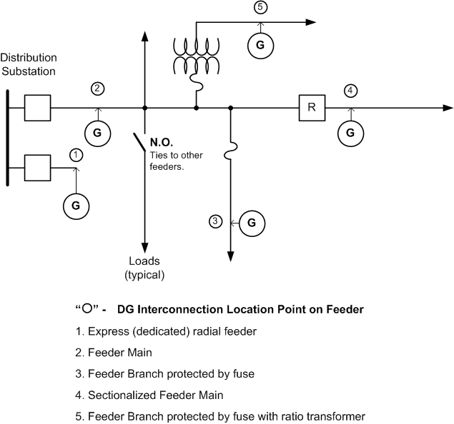

Table 4.6-1: Typical Planning Limits for DG Connection to Radial Distribution Feeder
Typical Gross Generation Capacity Limit (see notes below)
DG Location on Feeder | 3-phase Radial Distribution  Voltage Class System
DG Location on Feeder | 4 or 5kV | 15kV
1. Express (dedicated) Radial Feeder | 2.8MVA | 9.0MVA
2. Feeder Main | 0.75MVA | 2.5MVA
3. Feeder Branch protected by Fuse | 75kVA | 250kVA
4. Sectionalized Feeder Main | 100kVA | 300kVA
5. Feeder Branch protected by Fuse with Ratio Transformer | 50kVA | 150kVA
Notes to Table 4.6-1:
a. These generation capacities are on a per-generator basis on full nameplate ratings and at unity power factor. It should be noted, however, that the aggregate generation (sum of the total gross generation of all DG systems connected to a particular segment of the Company’s system) is considered for all points along the distribution feeder. The Company will evaluate each application before deciding on the maximum MVA allowed onto the Company’s system at a given point.
b. Limits apply to synchronous and induction rotating generator machines. The DG facility shall maintain power factor at the PCC in accordance with the MA SIDG; at 0.90 Power Factor leading or lagging (for Var or voltage support can also be considered within machine ratings). See ESB 750 regarding disturbances and capacitor installation.
c. Inverter-based systems such as Photovoltaic (PV) Systems are limited in aggregate to 500kVA on 4 or 5kV and in aggregate of large units 500kVA and above up to 3.0MVA on 15kV class systems (this is in addition to small (e.g. residential rooftop) PV until aggregate of these exceeds 500kVA). Operating issues on EPS voltage regulation occur from the effects of cloud transients on large PV systems.
d. Limits for 25kV and 38kV distribution class systems in Massachusetts are determined by the Company on a case-by-case basis.
e. On single-phase radial distribution systems, generators over 50kVA may require three-phase service. These situations will be determined by the Company on a case-by-case basis.
- Connecting customer generation to the low voltage network poses some unique issues for the Company; see Section 3.0 above. The generation can cause the power flow on network feeders to shift (i.e., reverse) causing network protectors within the network system to trip open. No synchronous generators are permitted for interconnection to the Company’s secondary voltage network systems. Small induction and inverter-based generators are considered on the secondary voltage network systems on a case-by-case basis.
- Connection of distributed generators on the spot networks is only permitted if the secondary bus is energized by more than 50% of the installed network protectors.
- From Table 4.6-1, DG facilities ranging in size from 750kVA to 2.8MVA at 4 or 5kV class or from 2.5MVA to 9.0MVA at 15kV class, and installed on non-network systems are considered for connection to express radial distribution feeders since the light load condition on the existing feeders may not meet the acceptable norm to avoid islanding (i.e., one third of the feeder’s all time light load must be greater than the aggregate nameplate distributed generation MW ratings). The EPS substation bus voltage regulation, transformer capacity, and high voltage side protection may be impacted by large DG systems and the Company may specify interconnection to a higher voltage EPS, which allows for continued growth of small DG on the Company’s Distribution EPS (e.g. residential solar). These issues refer to “DG saturation” such that it becomes technically infeasible to operate on a single distribution feeder. The Company will identify DG saturation in screening and feasibility reviews and in the results of impact studies for DG applications. Studies will be more complex and accommodating interconnections will likely require more involved infrastructure development, costs, and duration to construct.
- Because of the severe safety and potential equipment damage issues associated with feeding power into a deenergized distribution system, a major design consideration of any customer generator installation is that THE GENERATOR SHALL NOT ENERGIZE A DE-ENERGIZED COMPANY CIRCUIT. The protection system shall be designed with interlocks and proper protective functions to ensure that there is proper voltage, frequency and phase angle conditions between the Company’s Distribution EPS before the generator is permitted to parallel. Because of the potential interference with reclosing on radial and automatic sectionalizing feeders and/or restoration operations on the utility system, AUTOMATIC RECLOSING OF THE CUSTOMER’S INTERTIE CIRCUIT BREAKER IS NOT PERMITTED. The only exceptions that allow a unit to automatically reconnect are certain inverter–based generation systems as permitted by the MA SIDG.
- The Company’s distribution substations are subject to fault duty limitations. Adding generation to the Company Distribution EPS increases the amount of fault current imposed on the substations and equipment on the feeder(s). Exceeding the fault duties at the substations and on the feeder(s) as a result of DG facilities will not be permitted and alternate methods of interconnection shall be explored where this limit has been reached.
- Multiple service facilities may be supplied to the Customer from a Company Distribution EPS. These service installations may be either dual primary switchgear or dual secondary transformers. To assure that the reliability and proper protection are maintained in these multiple service facilities, the Customer is not permitted to:
- Parallel secondary services from a common facility.
- Parallel secondary facilities supplied from separate locations.
- Exceed the ampacity rating of any service facility.
- Create an unbalanced loading condition between phases of a service.
The interconnection of multiple services above 600 volts shall be specified by the Company within the Company’s operating practices and electric service requirements to ensure safety to the public, to Company employees, and to the Customer.

General Design and Operating Requirements
From the perspective of interconnection, there are three main types of customer generation systems that interface to the Company’s Distribution EPS. These include:
- Induction Generators
- Static Power Converters (inverter-based)
- Synchronous Generators
Each type has its own specific characteristics regarding synchronization equipment, protective functions, starting practices, and electrical operating behavior. There may also be additional specific requirements that may be identified as part of any Impact or Detailed Study that is performed for a specific location.

Applicable Codes, Standards, and Guidelines
- The Customer’s DG facility shall conform to the latest revision of all local, state and federal codes and national standards that apply. Specific standards applicable to this bulletin include, but are not limited to:
- Institute of Electrical and Electronics Engineers (IEEE) Std. 1547 “Standard for Distributed Resources Interconnected with Electric Power Systems”
- Underwriters Laboratories (UL) Std. 1741 “Inverters, Converters and Charge Controllers for Use in Independent Power Systems”
- NFPA 70 “National Electrical Code” (NEC)
- NFPA 70B “Recommended Practice for Electrical Equipment Maintenance”
- NFPA 70E “Standard for Electrical Safety in the Workplace”
- NETA-MTS "Maintenance Testing Specifications for Electrical Power Distribution Equipment and Systems"
- The Customer’s DG facility shall also conform to any applicable requirements of the Massachusetts DPU and any local, state, federal and/or other agencies from which a review, approval, or a permit is required.
- The minimum “fall zone” clearance of wind turbine generators (WTG) shall be in accordance with the local governmental authority having jurisdiction (AHJ) and in any case, shall not be less than 125% of maximum WTG height measured horizontally to the Company’s overhead distribution lines.
- The Customer shall comply with the appropriate Company ESB or tariff requirements, which cover details for the Customer’s electric service installation. These include:
- ESB 750 - Specifications for Electrical Installations
- ESB 751 - General Requirements Above 600-volt Service (under development)
- ESB 752 - Service Above 15,000 volts
- ESB 753 - Primary Meter Pole
- ESB 754 - Outdoor Pad Mounted or Vault Enclosed Single and Three Phase
Transformer
- ESB 758 - Primary Service to Metal Enclosed Gear
- M.P.D.U. 1176 - Massachusetts Electric Company Nantucket Electric Company d/b/a National Grid Standards for Interconnecting Distributed Generation (MA SIDG)
- M.D.P.U. 1192 - Massachusetts Electric Company Nantucket Electric Company Terms and Conditions for Distribution Service
Refer to Exhibits 5 and 6 and Figures 1 through 4 for information when submitting single-line diagrams to the Company’s TSES department (electronic mail address: Distributed.Generation@nationalgrid.com).

Definitions
See the MA SIDG for definitions of special terms.

General Criteria
The interconnection of all parallel generators requires safeguards for synchronization and back feed situations in accordance with the MA SIDG. Each specific connection must be studied with respect to size, type, and the nature of the Company’s Distribution EPS at the POI. Only the results of a specific study can indicate the suitability of a given generator connection to the Company’s Distribution EPS and its possible economic viability. See the MA SIDG for detailed requirements.

Single Phase
Single phase parallel generator connections to Company Distribution EPS circuits under 600 volts present power quality and phase balance challenges. Single phase connections shall have these minimum characteristics:
- Nameplate rating of a single generator or group of generators equal to or less than 50kVA (see Note “e” to Table 4.6-1).
- Configured as a three-wire, line-to-line with neutral, or line-to-neutral with adequate load balance.
- A dedicated service lateral with a dedicated transformer, when required by the Company.

Three Phase
Three phase connections are required in all other instances.

Phase Balance
The Customer’s DG facility shall permit equal current in each phase conductor at the service point. Voltage unbalance resulting from unbalanced currents shall not exceed 2% and shall not cause objectionable effects upon or interfere with the operation of the Company’s facilities and service to others. This criterion shall be met with and without generation.

Neutral Stabilization and Grounding
Where the Customer is served from a Company four-wire multi-grounded neutral distribution circuit, adequate grounding must be provided to ensure neutral stability during accidental isolation of the line from the main system. This may require an additional ground source. Adequate grounding can be provided either by the use of wye-delta main power transformer (see Section 5.5) or by installing an appropriate grounding transformer. The effects of such grounding on the Company’s ground-relay sensitivity shall be limited.
As a minimum, the Customer’s generation equipment shall be grounded in accordance with the latest requirements of the National Electrical Code (NEC). For specific installations, refer to the applicable sections of this document and the Company’s ESB 750. The Company requires ground protection on any system that can be a generation source and to protect transformers that can be paralleled and supplied from two sources. When generator tripping is needed to sense ground faults on the Company’s Distribution EPS:
- The winding arrangement of the Customer’s DG facility transformer shall be such that the Company’s system remains effectively grounded (see Section 5.5.3).
- The Company may require that the grounding impedance be limited to the highest value suitable for neutral stabilization (see Section 5.7.2), or to limit generator ground fault contributions (see Section 5.7.5).
- A “zero-sequence” voltage or “3V₀” or “GV3” scheme will be required on the primary side of a delta primary wound transformer supplying the DG facility; see Figure 4.

Service Equipment and Revenue Metering

Service Equipment Requirements
- The Customer shall provide service entrance equipment as a part of their installation; see the Company’s ESB 750. The Customer’s service equipment shall be rated, at a minimum, for the maximum fault current available from the Company Distribution EPS and their own contribution from the generator(s), motors, etc.
- At the service entrance equipment, the Customer shall have a permanent directory plaque to indicate all electric sources and the Generator Disconnect location(s) on their premise according to the NEC.
- For large DG Customers with generation systems equal to or greater than 500kW, refer to the typical primary overhead service configuration requirements in Exhibit 7.

Company Revenue Metering Requirements
- The Company will specify the location and arrangement of all equipment required for the revenue metering of the Customer’s service and DG facility. Reference the Company’s ESB 750, Section 7 for additional information and requirements. The Company’s electricity tariff, M.D.P.U. 1177, describes qualifications for net metering.
- An analog/POTS (Plain Old Telephone Service) telecommunications line to each Company-owned revenue meter location shall be provided by the Customer. The telephone line shall be capable of direct inward dial without human intervention or interference from other devices such as fax machines, etc.

Transformer

Purpose for DG Facility Interconnecting Transformer
A transformer at a DG facility serves three purposes. First, it enables proper voltage matching between the generator and the utility connection. Second, it acts as a buffer to limit any current contribution from the DG facility in the event of a short circuit on the electric system. Third, it can ensure effective grounding of the utility circuit when the DG is exporting power.

Secondary Served DG Customers
Where the Company provides secondary service, the Company’s transformer is an equipment standard for service delivery voltages; see Section 3 in ESB 750. Non-standard transformers are not provided by the Company. The Company will determine when dedicated services and a dedicated transformer are required in order to reduce the impact on other adjacent customers. The need for a dedicated transformer(s) may be determined at any point in the generator’s life cycle. If a dedicated transformer(s) is required, the Customer will be advised by the Company in writing. The cost of the transformer(s) will be the responsibility of the Customer according to M.D.P.U. 1192 and as permitted by the MA SIDG. DG projects need to be aware that the distribution EPS at rural locations will have single-phase loads on the feeders where phase impedance is typically unbalanced.

Primary and Higher Voltage Served DG Customers
The Company reserves the right to specify the winding connections for the Customer’s “step-up” transformer between the Company’s delivery point and the Customer’s DG facility’s output voltage as well as whether it is to be grounded or ungrounded. The Customer shall provide their interface “step-up” transformer’s specifications and ratings for the Company’s review in the impact and detailed studies.

Effectively Grounded, Four-wire Multi-grounded 3-phase Wye EPS:
The Company requires that all interface transformers be configured to have a wye connected primary winding with a fully insulated neutral, and the secondary winding to have a delta connection.
- If infeasible, an alternative that is subject to Company acceptance review is a primary wye grounded - secondary wye grounded transformer requiring a grounded source permitted under specified conditions.
- Any DG or aggregate DG below 500kW in a Customer’s facility may be permitted to utilize a primary delta - secondary wye grounded transformer.
- Where any DG or aggregate DG is 500kW or greater in a Customer’s facility, ungrounded transformers (i.e. primary delta or Yg-Yg with ungrounded source) are not permitted on any Company-owned effectively grounded, four-wire multi-grounded 3-phase wye circuits.

Not Effectively Grounded, Three-wire 3-phase EPS:
The Company only allows the connection of delta primary interface transformers on three-wire not effectively grounded 3-phase primary and high voltage circuits. Refer to Section 5.3.4 for grounding requirements such that the generator does not contribute to line-ground faults on the Company’s EPS.

Manual Generator Disconnect Switch
- According to the MA SIDG, inverter-based systems 25 kW and below are not required to have a separate disconnect if the unit has a disconnecting means integrated into the design and meets the requirements of the National Electrical Code (NEC).
- For those projects requiring a disconnect switch (or comparable device mutually agreed upon by the Company and the Customer) at the point of DG facility interconnection that can be opened for isolation, these isolation devices shall be rated to interrupt the maximum generator output; meet applicable Underwriters Laboratories (UL), American National Standards Institute (ANSI), and IEEE standards; and shall be installed to meet the NEC and all applicable local, state, and federal codes.
- The Customer’s DG facility shall have an electrical load break disconnect switch accessible at all times to the Company to electrically isolate the Company’s Distribution EPS from the Customer’s generator facilities.
- In accordance with the Company’s safety rules and practices, this isolation device must be used to establish a visually open, working clearance boundary when performing maintenance and repair work. The designated generator disconnect also must be accessible and lockable in the open position and have provisions for both Company and Customer padlocks and be capable of being tagged and grounded on the Company side by Company personnel.
- The visible generator disconnect switch shall be a gang-operated, blade-type switch (knife switch) meeting the requirements of the NEC and nationally recognized product standards. Pull-out switches commonly used in air-conditioning units and spas are not permitted for this application. The visible break requirement can be met by opening the enclosure to observe the contact separation. The Company shall exercise such right in accordance with Section 7.0 of the MA SIDG.
- The connection of the disconnect switch shall have the line connection (i.e., jaw side) of the switch made to the utility source.
- Additionally, the Customer is solely responsible for the maintenance of all fuses in fused, blade-type disconnect switches.
- This disconnect device shall be identified by a permanent sign as required by the NEC and the MA SIDG.
- For 4 or 5 or 15kV class interconnections, the DG Customer shall use a lockable, 15kV, 3-phase, gang-operated disconnect switch at the PCC. The DG Customer shall provide the Company with 24-hour/7-day unlimited access and control of this isolation switch.

Protective Device Equipment

Protection Requirements
All DG facilities shall meet performance requirements set forth by Section 4.2.3 in the MA SIDG. DG types of interconnection are categorized as either Group 1 “Facilities Qualified for Simplified Interconnection” or Group 2 “All Facilities Not Qualified for Simplified Interconnection” according to the MA SIDG. The Under Frequency relays for the Group 2 DG facilities shall not trip at frequencies higher than the curve provided for the “Eastern Interconnection Generator Tripping” in Figure 1 of the PRC-006-NPCC-1 Automatic Underfrequency Load Shedding criteria specified in the MA SIDG.
The DG Customer’s interconnection system shall have the capability to withstand voltage and current surges in accordance with the environments defined in the latest IEEE Standard C62.41.2 or IEEE Standard C37.90.1 as applicable.

Interconnection Interrupting Device
An interconnection interrupting device such as a circuit breaker shall be installed on the high voltage side of the interface transformer to isolate the DG facility from the Company’s EPS. If there is more than one interrupting device, this requirement applies to each one individually. The interconnection interrupting device shall be capable of interrupting the current produced when the DG facility is connected out of phase with the Company's EPS.

Interconnection Transformer Configuration
In order to avoid Over Voltage (OV) on the distribution customers, it is National Grid’s policy that any Distributed Generator equal or above 500kW connected to a four wire distribution feeder should provide an effectively grounded system with respect to the Company’s EPS; see Sections 5.3.4 and 5.5 for grounding and transformer requirements. Contributing to the faults on the Company’s four-wire distribution EPS can desensitize the relays at the Company’s substation. Hence, it is required that the DG Customer provide a fully insulated neutral bushing for the primary wye winding of the step-up transformer and install a fault current limiting grounding reactor to limit the fault current to 3 times the generator rating. The grounding reactor shall not violate the effectively grounded system requirements. The inductive value of the reactor will be specified by the Company.

Instrument Transformers for Protective Device Relays

Current Transformers (“CT”)
CT ratios and accuracy classes shall be chosen such that secondary current is less than 5 amperes normal operation, 100 amperes under maximum fault condition and transformation errors are consistent with Company practices.

Voltage Transformers (“VT”) and Connections
See Sections 5.3.4 and 5.5 for transformer requirements. The DG facility shall be equipped with a direct voltage connection or a VT, connected in accordance with the Company’s requirements. The DG Customer is responsible for over voltage detection and the detection of line-to-ground faults on the primary and secondary sides of the step-up transformer as well as the Company’s EPS. For wye reactively grounded primary, delta secondary transformers, the DG Customer is required to install Yg-Yg VTs on their transformer secondary delta winding which will have the dual purpose to detect the voltage depression on the faulted phase on low voltage line-to-ground faults to enable the operation of the 51C controlled overcurrent elements when faults occur on the Company EPS, as well as, detect the over voltage on the unfaulted phases for single phase-to-ground faults on the delta side of the step-up transformer. The use of Yg-Open Delta VTs will be considered by the Company on a case-by-case basis.

Synchronizing Devices
The DG Customer shall designate one or more Synchronizing Devices such as motorized breakers, contactor/breaker combinations, or a fused contactor (if mutually agreeable) to be used to connect the DG facility’s generator to the Company’s EPS. This Synchronizing Device could be a device other than the Interconnection Interrupting Device. The Synchronizing Device must be capable of interrupting the current produced when the Facility is connected out of phase with the Company's EPS.

Voltage Relays
Voltage relays shall be frequency compensated to provide a uniform response in the range of 40 to 70 Hz.
See Sections 5.3.4 and 5.5 where the DG Customer needs to install Yg/Yg instrument voltage transformers (VT) on their transformer secondary delta winding to detect overvoltage on unfaulted phases caused by single line-to-ground faults and provide voltage detection for a voltage controlled overcurrent (51C) element, which will trip the high side interrupting device.

Frequency Relays
Over and Under Frequency relays shall meet IEEE 1547 requirements. In addition, Group 2 DG facilities shall not be set above the “Eastern Interconnection Generator Tripping” curve of Figure 1 “Thresholds for Setting Underfrequency Trip Protection for Generators” in PRC-006-NPCC-1 “Automatic Underfrequency Load Shedding” criteria specified in the MA SIDG.

Overcurrent Relays
See Sections 5.3.4 and 5.5 for transformer requirements. Overcurrent protection is required on the high side of the DG Customer’s interface transformer to detect faults on the Company’s EPS. Voltage controlled overcurrent elements (51C) are required for both phase and ground. These relays shall utilize voltage sensing via the Yg-Yg VTs on the DG Customer’s transformer secondary delta winding to detect the single line-to-ground faults. The 51C elements shall trip the high side interrupting device.

Type Tested Equipment
Protective equipment that has been type tested and recognized under UL Standard 1741.1 by the MA SIDG for Group 1 DG facilities will be permitted. The Customer shall follow the testing requirements as outlined in the MA SIDG. Exhibit 8 attached is a guide for the Company’s witness for verifying a type tested net-metered DG installation’s operational compliance.

Non-Type Tested Equipment
Protective equipment that has not been type tested per the MA SIDG and considered as Group 2 DG facilities will be permitted with the implementation of utility grade protective devices acceptable to the Company. The use of utility grade relays and relay redundancy is acceptable subject to prior Company review and acceptance. It is the Company’s policy that any DG equal or above 500kW requires redundant relaying. At the Company’s discretion the Company reserves the right to require redundant utility grade relays for systems 250kW and above. The relay specifications are classified as follows:

Photovoltaic (PV) Generation
IEEE 1547 compliant and UL-1741 certified inverters shall be equipped with an internal anti islanding scheme and active under voltage (27), over voltage (59), zero sequence over voltage (59N), under frequency (81U) and over frequency (81O) relays.

Inverter-based PV Generator Equal or Above 500kW
The internal relays are considered as primary protection and the Company requires one additional utility grade relay to be installed as the secondary protection if the inverter-based PV size is equal or above 500kW. The 27, 59, 59N, 81U/O and voltage controlled over current 51C (Phase and Ground) elements shall be activated in the redundant relay. The utility grade relay failure alarm shall be wired to the Company-designated generator interrupting device. If the step-up transformer configuration is primary wye grounded - secondary delta, the over voltage element (59N) shall have the capability of detecting the Line-Ground faults on the delta side and trip the high side (utility side) interrupting device to separate the Company’s EPS from the Line-Ground faults on the delta side (customer side) of the step-up transformer.

Inverter-based PV Generator Below 500kW
If the inverter is IEEE 1547 compliant and UL-1741 listed, the internal relays are considered as the only required protection and an additional utility grade relay is not necessary to be installed.

All Other Parallel Generation Equal or Above 500kW
For any generator equal or above 500kW, if the generator is equipped with internal relays with 27, 59, 59N and 81U/O relays, one utility grade relay is required to be installed as the secondary protection. Otherwise, two utility grade relays and one Company-designated interrupting device shall be installed to meet the protection requirements. The relay tripping scheme for the non-PV generators is the same as that of the inverter-based PV type.

Protective Relay Hard-Wire Requirement
Unless authorized otherwise by the Company, protective relays shall be hardwired to the device they are tripping. Further, interposing computer or programmable logic controller or the like is not permitted in the trip chain between the relay and the device being tripped.
The interconnecting relay shall be hardwired to the interconnecting interrupting device at the point of interconnection. There shall be no interposing programmable logic controller in the trip circuit.
Meter selector switches shall not be connected into the secondary circuits of current transformers used with protective relays specified by the Company.

Interconnection Interrupter Tripping and Protective Relay Supply
Interconnection interrupting devices shall have DC trip coils and tripping energy shall be derived from station batteries. Battery voltage, capacity specifications, and charging system provisions are subject to approval by the Company.
Control circuits associated with protective relays shall be DC powered from a battery and battery charger system. The battery shall be the sole source of tripping energy. Solid state relays shall be self-powered or DC powered from a battery and battery charger system.
If the DG facility uses a Company approved non-latching interconnection contactor, AC powered relaying may be permitted provided the relay as well as its method of application are fail-safe, meaning that if the relay fails or if the voltage and/or frequency of its AC power source deviate from the relay’s design requirements for power, the relay or a separate fail-safe power monitoring relay acceptable to the Company will immediately trip the generator by opening the coil circuit of the interconnection contactor.

Use of Microprocessor Based Relays
1. Number of Relays Required:
Where relay performance may affect the operation of the Company’s Distribution EPS at service voltages less than 15kV, a single microprocessor-based relay along with a Company approved scheme, where relay failure automatically trips the associated breaker(s), is acceptable. If the Customer decides not to use redundant microprocessor based protection systems on their other equipment, then appropriate action such as removing equipment from service shall be taken when a piece of equipment is no longer adequately protected.
2. Test Switches:
Microprocessor relays shall have ABB FT-1, or equivalent, test switches isolating all inputs and outputs of the relay.
Each relay designated by the Company as necessary to protect its electric system shall have its own test switch for AC and DC inputs that are associated with, and only with, that relay. DC test blades isolate the positive and negative DC for each input and output.

Utility Grade Protective Device Settings and Verification

Company-designated Relays and Customer Settings
The Company will review the Customer’s settings and their calibration and test results of those relays that the Company's engineering department designates as being required to satisfy the Company protection practices. Any relay setting specified by the Company shall not be changed or modified at any time without the written consent of the Company.

Company Verification of Relay Testing
The Company requires a letter from the Customer stipulating that all Company–designated protective devices shall have:
- control wiring verified against the accepted design drawings, and,
- the calibration test performed satisfactorily according to the relay setting document of the accepted design.
The Company reserves the right to witness the Customer’s functional test of the required devices, i.e., trip tests. This activity will normally be performed on a schedule as specified by Section 4.2.4 in the MA SIDG.
The Customer shall be responsible to specify the settings, calibrate, test, and maintain the balance of their equipment.

Anti-islanding
The Customer’s generation facility will not be permitted to energize a de-energized Company circuit. The IEEE 1547 states that anti-islanding protection is required for parallel generation on the EPS. The Customer may propose various methods of anti-islanding protection of their own generation facility. It is the Customer’s responsibility to demonstrate comprehensively the validity of such methods and the Company reserves the right to make the final determination as to which anti-islanding protection method is suitable. The use of direct transfer trip (DTT) is a definitive protection means for anti-islanding protection under good utility practice. Due to normal operation of Company switches, circuit breakers, and reclosers, the Customer’s DG facility may be islanded with only a portion of the total feeder load. The Company evaluates anti-islanding protection for minimum load on the entire feeder and on the smallest switched feeder segment that may be connected to the DG.
Note: A Customer wishing to use a generation system as a stand-by or emergency generator shall submit details regarding an interlocking scheme, or transfer switch to prevent the energization of a de-energized Company circuit that complies with National Grid ESB 750, Section 11.
Direct Transfer Trip (DTT) may be specified for the following conditions:

Inverter-based Photovoltaic (PV) Generation
Relays at the Customer’s DG facility and the Company’s substation should be capable of detecting all four types of faults in the EPS. There may be conditions where intentional opening of the substation feeder breaker/recloser or in-line reclosers could cause the Customer’s DG to island where the DG facility continues energizing the islanded feeder for more than 2 seconds. Those conditions can be classified as follows:

Load and Generation Match and Reactive Power Source in the Feeder Greater than 33% Generation
If there is a chance that minimum load on the feeder is close to the maximum generation such that the system frequency of the islanded feeder falls within acceptable range and the amount of reactive power being generated by the feeder capacitor banks in the islanded section of the feeder is above 33% of the inverter-based PV generation nameplate rating, there is a chance that the PV may create an island. Further transient analyses for dynamic conditions are required to determine the PV DG system’s run-on time. In this case, DTT will be required to shut down the generator system in less than 2 seconds once the island forms. DTT may also be required for run-on time less than 2 seconds, if the analysis shows that damaging over-voltages could occur during that period.

Multiple Generators Containing PV on EPS
If the inverter-based PV generation is connected to a feeder that is already connected to reciprocating generators and the aggregate size of the reciprocating (i.e. synchronous or induction) generators is larger than 20% of the PV rating, a transient analysis for dynamic conditions is required to determine whether or not the island will form. The reciprocating generator can deactivate the inverter’s anti-islanding scheme by tending to decelerate the rate of change of frequency due to the rotor inertia and absorbing reactive power for self excitation. The reactive power being injected by the inverters to perturb the frequency and detect the islanding condition may not be sufficient in the presence of the reciprocating generators.

All Other Parallel Generation Except PV Generators
If the minimum load on the feeder is above 3 times the maximum generation, DTT is not required. Otherwise, a transient analysis for dynamic conditions and a protective device coordination study are required to determine whether or not the islanding condition can form.

High-Speed Protection
The DG facility may be required to use high-speed protection if time-delayed protection would result in degradation in the existing sensitivity or speed of the protection systems on the Company’s EPS.

DTT Installation Requirements
When DTT is specified for a parallel generation project, the Company will determine the requirements for equipment, installation, and communications media in the interconnection study. The communication option selected in the interconnection study must be agreed upon by all parties. The DG Customer shall bear the responsibility for cost and securing equipment on their property and contribute to the associated costs, including any recurring costs, for the Company’s equipment in accordance with the applicable Company tariff.

Power Quality Compliance Verification
If during the study a DG interconnection project is identified as having the potential to cause power quality (PQ) effects on the EPS, then PQ monitoring shall be installed by the Company or Company-accepted third party PQ testing company to verify power quality with and without generation. Third party PQ test methods and results may be submitted to the Company for review and acceptance. These verification tests shall include, at a minimum, the following in accordance with the Company’s electricity tariff, M.D.P.U. 1192 and the limits and cost responsibilities specified in the MA SIDG:
- Check service point voltage for any discernible voltage fluctuation.
- Check service point frequency for any discernible frequency fluctuation.
- Check service point power factor to ensure it is no less than 90% (leading or lagging).
- Check service point harmonic distortion to ensure limits specified in ESB 750 and the MA SIDG as applicable, are maintained. Current harmonic distortion shall not adversely affect voltage harmonic distortion, the Company Distribution EPS, or service to other customers.

OPERATING

Power Factor
The Customer’s overall (leading or lagging) power factor at the service point shall not be less than 90% or that which is permitted at the PCC by the MA SIDG. Corrective equipment may be required; if so, refer to ESB 750.

Power Quality Monitoring
- If disturbances on the EPS and/or to other customers are determined to originate from a Customer with DG, PQ monitoring shall be installed to verify power quality in accordance with the Company’s electricity tariff, M.D.P.U. 1192.
- If any power quality concerns cannot be corrected, the Customer will not be permitted to continue generation until such concerns are resolved to the Company’s satisfaction.

Isolation
Pursuant to Section 7 in the MA SIDG, the Company reserves the right to have the Customer remove their generation from the Company Distribution EPS at any time upon the Company’s request. Normally, such requests result from the need to facilitate maintenance, test, or repair of Company facilities. The Customer’s generator disconnect switch may be opened by the Company (i.e., isolating the Customer’s generating equipment), without prior notice to the Customer, for any of the following reasons:
- System emergency operations require such action.
- Company periodic checks of Customer’s interfacing equipment reveal a hazardous condition.
- Generating equipment interferes with other customers or with the operation of the Company Distribution EPS.
- Protective device tampering.
- Parallel operation, other than for MA SIDG testing of type tested inverters, prior to Company approval to interconnect.
- Failure to make available records of verification tests and maintenance of the Customer’s protective devices designated by the Company.

Energy Management System-Remote Terminal Unit (EMS-RTU)
For distributed generator (DG) facilities,
- Less than 1MW, if there is feeder selectivity operation, then the Company may require an EMS-RTU.
- 1MW or greater, the Company requires an EMS-RTU for status and control of the generator.
The required inputs from the RTU to the Company’s EMS are as follows:
- Status of individual generator breakers
- Status of main or interconnect breaker at the point of common coupling (PCC)
- Three phase line current for each generator
- Three phase line current at the PCC with the Company
- Three phase line-to-line voltage for each generator
- Three phase line-to-line voltage at the PCC with the Company
- Output kW for each unit (+ delivered to the Company, - received)
- Output kVAR for each unit (+ delivered to the Company, - received)
- Total MW (+ delivered, - received) at the PCC
- Total MVAR (+ delivered, - received) at the PCC
Exceptions to the above list may be considered by the Company on a case-by-case basis.
Note: The Company will provide an EMS-RTU point list for inputs required at the DG facility.
The control portion would only involve the remote trip and block closing of the Customer’s automated disconnect device designated by the Company. The block close function will be performed by control circuitry and is subject to Company acceptance review.
When a Company EMS-RTU is specified for a parallel generation project, the Company will determine the requirements for equipment, installation, and communications media in the interconnection study for the DG facility. The DG Customer will be responsible for all initial and recurring costs associated with MPLS communications for their RTU.

Balance of Customer Equipment
- The Customer is responsible for performing all operating functions associated with their equipment and for maintaining all equipment under their ownership. The Customer shall arrange to have trained personnel available for the proper and safe operation of their equipment.
- The Customer shall provide proper and continuous maintenance of all plant facilities; refer to National Fire Protection Association (NFPA) recommended practice NFPA 70B (and NFPA 73 where applicable) and other nationally recognized industry guides for guidance on electric equipment maintenance. See also the Company’s ESB 755.
- Where the Company is requested to supply demand pulse information (either analog or digital), its use is not intended for generator control.

REVISION HISTORY
Version Date Description of Revision
1.0 06/01/07 Initial version of new document superseding all previous revisions of ESB 756.
1.1 07/29/11 September 2010 ESB 750 Series Errata changes, formatting, and general editing.
2.0 05/11/12 Revised and formatted incorporating technical requirements of MA DPU 1176 Dec. 2009.

EXHIBITS ATTACHED

EXHIBIT 1: M.D.P.U. 1176 Tariff
https://www.nationalgridus.com/masselectric/non_html/rates_tariff.pdf
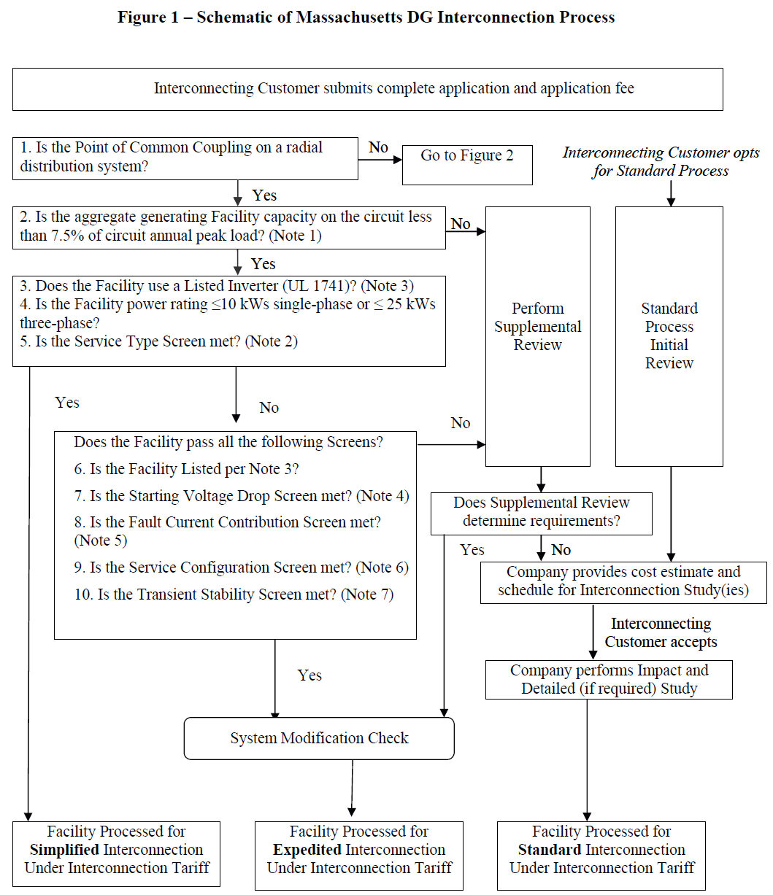

For explanatory notes accompanying Figure 1, see M.D.P.U. 1176, sheet 17.

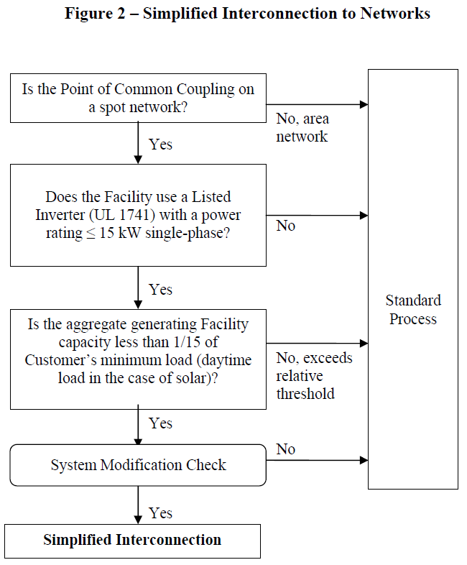

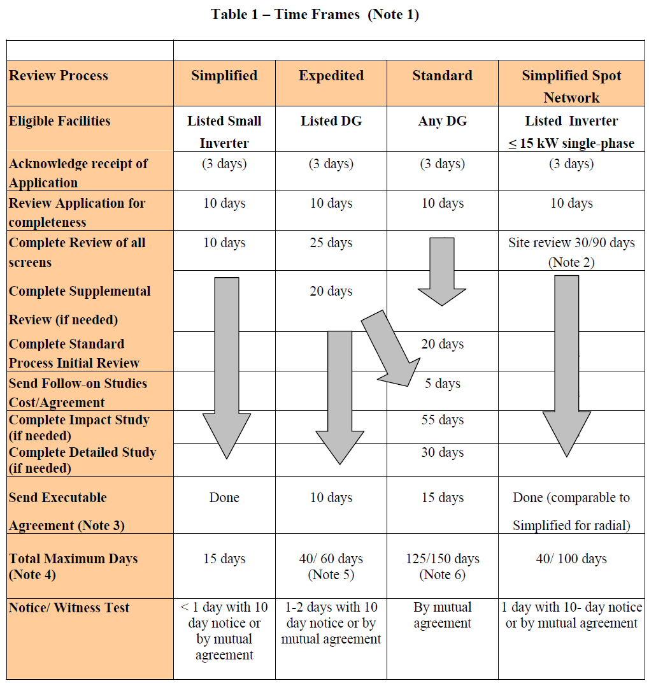

For explanatory notes accompanying Table 1, see M.D.P.U. 1176, sheet 22.

EXHIBIT 2: Company Requirements for Projects Not Eligible for the Simplified Process
These are Company items to be considered in the Customer’s DG Project Schedule.
ID | Activity Description | MA SIDG § or ESB ref.
Project Definition & Conceptual Analysis Phase
1 | Customer M.D.P.U. 1176 Exhibit B Expedited/Standard Interconnection Application Form w/technical submittal & prelim. design received | 3.2 or 3.3, Figure 1, Table 1
2 | Company Preliminary Technical Assessment & cost estimate for Impact or Detailed Study | 3.0, Table 2
3 | Company M.D.P.U. 1176 Exhibit F or G Retail Connection Agreement executed with Customer | Exhibit F or G
4 | Customer commits to Impact or Detailed Study and provides advance payment | 5.0
Final Design Review Phase
5 | Company completes Impact or Detailed Study/Service Plan | 3.2 or 3.3, Figure 1, Table 1
6 | Customer commits to utility system modifications in Impact or Detailed Study/Service Plan and provides advance payment | 4.0, 5.0
7 | Customer's project schedule and final design & specifications received | 4.0 – 8.0, ESB 750 & 752 or 753 or 754 or 758
8 | Company reviews Customer’s design & returns comments | 4.0 – 8.0, ESB 752 or 753 or 754 or 758
Installation Progress Review Phase
9 | Customer’s corrected design, test reports & settings received | 4.0 – 8.0, ESB 752 or 753 or 754 or 758
10 | Company reviews Customer’s design & returns comments | 4.0 – 8.0, ESB 752 or 753 or 754 or 758
11 | Company field audit of Customer’s installation progress | 4.0 - 6.0
Installation Compliance Verification Phase
12 | Customer’s advance notice of functional testing received | 4.2.4, ESB 755
13 | Electrical inspection certification approval received from municipal codes enforcement | ESB 750 & 752 or 753 or 754 or 758
14 | Customer’s acknowledgement of satisfactory wiring & relay calibration tests received | 4.2.4, ESB 755
15 | Company witness of Customer’s functional testing | 4.2.4, ESB 755
16 | Company field audit of Customer’s service connection | 4.0 – 6.0, ESB 750 & 752 or 753 or 754 or 758
17 | Customer resolves open items | ESB 750 & 752 or 753 or 754 or 758
Energization & Synchronization Phase
18 | Verification testing satisfied | 4.2.4
19 | Company’s metering installation complete | 8.0, ESB 750 & 752 or 753 or 754 or 758
20 | Company’s supply system interconnection complete | 4.0, 5.0
21 | Company review/acceptance of Customer’s resolved open items
22 | Customer’s Certificate of Completion received (and energization sequence plan for interconnections >600V) | 3.2 or 3.3, ESB 755
23 | Company proceeds with energization
24 | Customer is permitted to synchronize generation facility in parallel to the Company’s supply
Project Closeout Phase
25 | For interconnections >600V, remainder of Customer’s protective system functional testing documented in an acknowledgement letter submitted to the Company within 10 business days after energization | ESB 755
26 | Customer’s as-built design drawings received within 90 days for interconnections >600V | ESB 750 § 1.7
27 | Company reconciliation of project costs with Customer | When requested by Customer.

EXHIBIT 3: Reference Maps of National Grid Massachusetts Secondary Network EPS Areas

Bay State North/West Division

Lynn and Worcester

Bay State South Division

Brockton

[Maps are to be developed.]

National Grid customers in the downtown districts of Brockton, Lynn, and Worcester can contact via E-mail addressed to Distributed.Generation@nationalgrid.com to determine if the proposed location is served in National Grid’s Secondary Network area.

EXHIBIT 4: Distribution Secondary Grid Network Description
In Massachusetts, National Grid generally has two types of electrical distribution systems: radial and distribution secondary network systems. While the vast majority of customers are served from radial power systems, some customers in the downtown districts of Brockton, Lynn, and Worcester in Massachusetts are served by distribution secondary network systems; see Exhibit 3 for area maps. These systems are designed to meet the higher reliability needs, dense load levels, and limited space commonly encountered in urban areas.
A distribution secondary network system delivers electricity through a complex and integrated system of transformers and underground cables that are connected and operate in parallel. Power can flow in either direction on the secondary service delivery lines, commonly called secondary distribution lines. The loss of a single line or transformer in a secondary network system does not cause an interruption of power, unlike radial systems where there is only one line and one path for power to flow from the distribution substation to the customer’s point of service. If a radial system experiences an outage, service is interrupted to the customers until repairs are completed; this is less likely to be the case in a distribution secondary network system.
In distribution secondary network systems, devices called “network protectors” are usually arranged to automatically connect its associated transformer to the network system when conditions are such that the transformer when connected will supply power to the network and to automatically disconnect the transformer from the network when power flows from the network to the transformer. The integration of DG into a distribution secondary network system may result in network protectors exceeding their original design criteria or nameplate ratings.

Example Distribution Secondary Grid Network Diagram 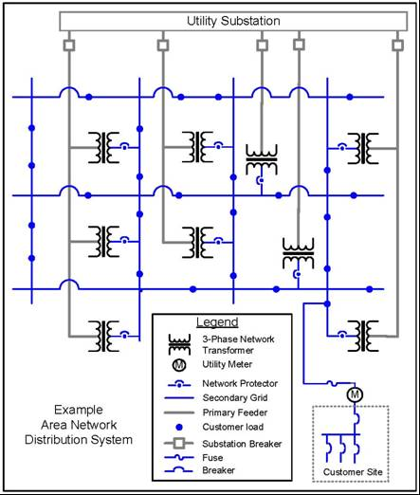

EXHIBIT 5: Recommended Guidelines for Residential and Commercial Single-line Diagram Submittals
Refer to Figures 1 and 2 for typical illustrations.
- Identify the project, Company’s electric service order (ESO) number, location and submitter’s name and address.
- Indicate standard and any non-standard system voltages, number of phases, and frequency of the incoming circuit. Indicate wye and delta systems; show whether grounded or ungrounded.
- Identify cable, conductors and conduit, the type and number. The Company is interested in how the power is getting from the service point to the protective equipment.
- Identify wiring troughs and/or junction boxes where used.
- Use standard symbols. See NFPA 70B or IEEE Standard 141 for symbols in typical electrical single-line diagram development.
- Identify the service equipment’s switch and fuse or circuit breaker as to manufacturer, type, rating, catalog number, etc. Catalog cuts are not required for most major manufacturers. Service equipment must be able to safely interrupt the maximum available fault current from the supply; refer to NEC Articles 110 and 230.
- Show billing meter trough or instrument transformers’ cabinet (C.T. cabinet) in circuitry. Indicate source and load for the circuit. Refer to Section 7 in the Company’s ESB 750 for acceptable metering configurations.
- Identify other protective devices and ratings. Include ratings in volts and amps, the interruption rating, and type and number of trip coils on circuit breakers. Also, note any special features of fuses (current limiting, dual element, etc.).
- Identify ratios of current and potential transformers, taps to be used on multi-ratio transformers, and connection of dual ratio current transformers if used.
- Identify any relays, if used, and their functions.
- Show connections and ratings of power transformer windings for any to be used.
- Identify Generator Disconnect and its ratings.

FIGURE 1: sample residential Photovoltaic distributed generator installation – Single Phase, Net Metering
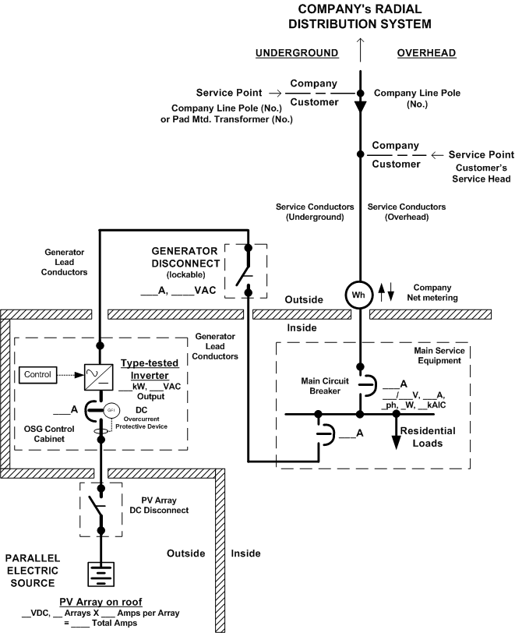

FIGURE 2: sample commercial distributed generator installation
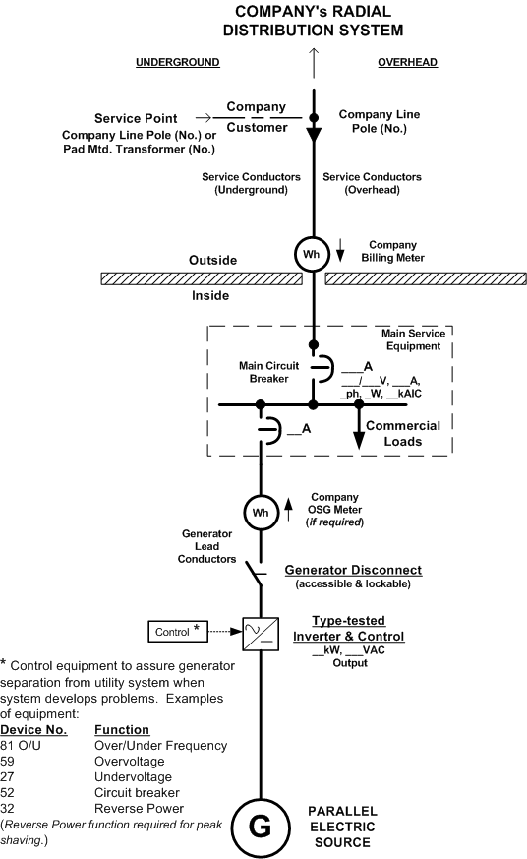

EXHIBIT 6: Recommended Guidelines for Functional Single-line Diagram Submittals
Refer to Figures 3 and 4 for typical illustrations.
In addition to Exhibit 5:
- On functional single-line diagram submittals, industry standard device numbers are necessary. Refer to the following List of Standard Device Numbers (See latest edition of ANSI C 37.2):

Device Number Function
25 Synchronizing Device
27 Undervoltage Relay
32 Directional Power Relay
46 Negative Sequence Voltage
50 Instantaneous Overcurrent Relay
51 Phase Overcurrent Relay
51N Neutral Overcurrent Relay
51V Overcurrent Relay, voltage restraint
51C Voltage controlled overcurrent
52 Breaker
52R Recloser
59 Overvoltage Relay
59G Neutral Voltage Relay
59N Zero Sequence Voltage Relay
62 Time-delay Stopping or Opening Relay
64 Ground Protective Relay
81 Over and Under Frequency Relay
86 Locking - Out Relay
87 Differential Relay

FIGURE 3: sample functional single-line diagram
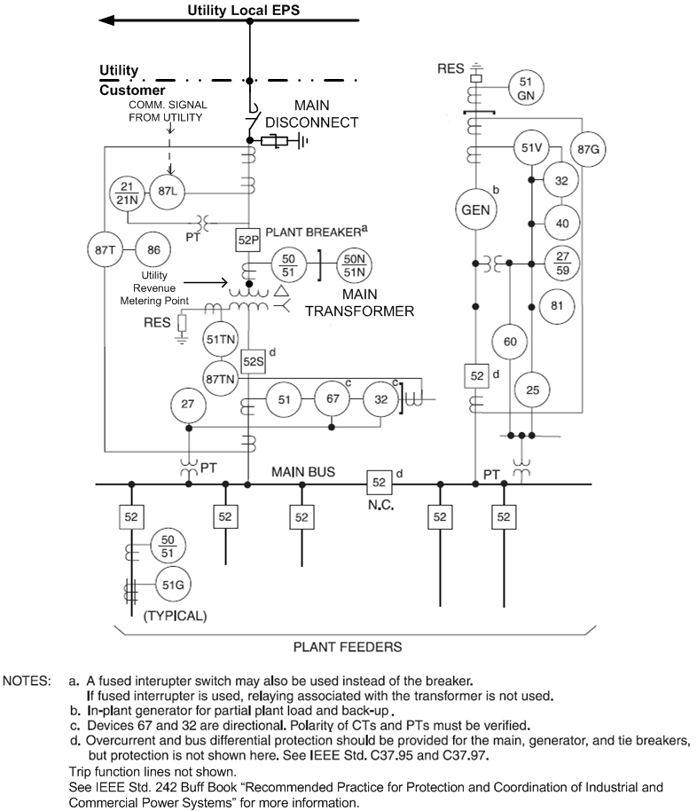
[TYPICAL ONLY]

FIGURE 4: typical 3v₀ requirements for local eps ground fault detection

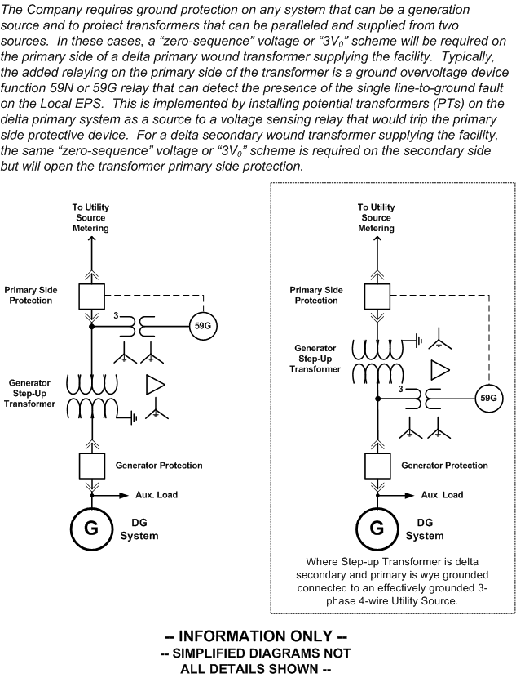

EXHIBIT 7: Typical Overhead Primary Service Configuration for Large DG Installations >500kW
The DG Customer will be required to install a pole to the Company’s specifications on which the Company will install cross arms and dead end the Company’s primary service conductors. This point will be the physical Point of Common Coupling (PCC). At this pole the Customer-owned, 3-phase gang operated, Generator Disconnect switch can be installed and connected to the Company’s primary service conductors by the DG Customer.
All Company-owned service lateral facilities and equipment on private property will require easements. These easements will be the responsibility of the DG Customer to obtain in accordance with the Company’s specific electric service requirements; see ESB 750.
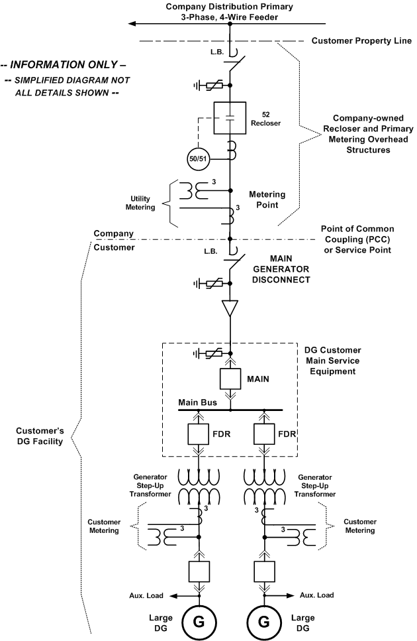

EXHIBIT 8: net metering compliance verification checklist (Simplified Process)


